Project PRoposal

Assessment 1

Kieran Abelen

Contents

Introduction 3

Implications 4

App description 4

Target audience 4

Project Consideration 4

Conclusion 5

Audio 6

Introduction 6

Considerations 6

Project 6

Development platform 6

Expert 6

Project Criteria 7

Quality assessment 7

Conclusion 7

Animation 8

Introduction 8

Usability 8

Considerations 8

Project 8

Development platform 8

Expert 8

Project Criteria 9

Conclusion 9

Shake animation 9

Collapse/Expand animation 9

Scale animation 9

Video 10

Introduction 10

Usability 10

Considerations 10

Project 10

Development platform 10

Expert 11

Project Criteria 11

Quality assessment 11

Container/Video format: MP4, Codec: H.264, Audio: AAC 11

Container/Video format: 3GP, Codec: MPEG4, Audio: AAC 13

Container/Video format: WebM, Codec: VP9, Audio: Opus 13

Conclusion 13

Graphics & Images 15

Introduction 15

Considerations 15

Project 15

Development platform 15

Experts 16

Project Criteria 16

Quality assessment 17

Conclusion 19

Text 20

Introduction 20

Usability 20

Considerations 21

Project 21

Development platform 21

Expert 21

Project Criteria 22

Quality assessment 23

Conclusion 24

Storyboard & Wireframe 25

Introduction 25

Storyboard 25

Wireframe 26

Usability 26

Project consideration 27

Conclusion 27

User Experience 28

Introduction 28

Usability 28

Project consideration 28

Conclusion 28

Conclusion 30

References 31

Project Proposal

# Introduction

This document will provide a plan for the development of a Character generator, before the plan the report will justify any deliverables that will be produced the project.

These considerations for a deliverable interactive media file will be reference by experts in their field alongside the realistic application with the development tool Visual Studio Community (Microsoft, n.d.)

Ever section topic will contain the following headings

1. I will introduce the topic with any relevant information
2. I will then ask what this information is relevant for usability
3. I will then introduce the project and my considerations
   1. I will refer to the Visual studio platform and Xamarin for guidance on the topic
   2. I will the source experts and break down their insights into the topic
   3. Finally, I will consider the project as a whole
4. Experimentation for quality assurance
5. Concluding with a topic solution

The final part of the report will be the plan for developing the app; using my researched justifications and Usability testing to have the best design for the development app.  
This will reduce risks and project failure.

# Implications

## App description

76PlayerCreator will be able to generate a character of an in-game comparison with Fallout 76. The character could be used to plan potential additions to your already existing Fallout 76 character.

## Target audience

The audience this app is for is first and foremost the player of the game, but the wider audience is gamers in general whose age ranges from 16-30

Finding this survey of the audience of a game set in the same universe helps clarify this demographic (Yetteh, 2016).  
This survey has one particularly interesting finding which is that 45% or the majority of the player base work so they will have less time but potentially more income to spend. This is a prime demographic for a time saving apps like this.  
21% counter to this point earned under 10k a year so offering a free but more limited feature version could be an option.  
56% of the players are single which means sharing builds and connecting with others players will be a higher priority to.  
64% play on PC so there maybe potential for a website or executable version of the app.

This one is more recent survey but it had less votes but also confirms the same audience but the 3 year difference suggests the audience is just a tiny bit older (SageSolus, 2018)

## Project Consideration

For the most part the audience are fallout fans first so sticking to tried and true information and likeness to the game will be the best thing to satisfy their audience.  
Further than the goal of the app extra features can target more specific things the audience embody for example a chat feature for people who are single to talk to like mind induvial.

Each demographic breakdown:

* 45% working players: This audience would really benefit from a time saving app like this. An even greater reason to target this audience so that they can use this app while on break while at work. Offering paid additions could be a potential for example limiting the amount of builds you can save but offering extra saves for a payed amount.  
  Pre-built templates might be a good addition so they don’t have to rebuild a basic character.  
  Since money isn’t an issue I expect the audience will have expensive devices to run this app so deliverables should be highest quality.
* 21% under 10k: The app could potential offer a free version with inbuilt ads.
* 56% single: A chat could be a good undertaking or sharing and posting build into a searchable database.
* 64% PC: further confirms the audience is working and would love a time saving app but even a release on pc that integrates into the app.

## Conclusion

There are some features I will not be able to do in the prototypes or alpha release but that doesn’t mean I shouldn’t consider them in development. Leaving my app component interactions open enough to add extra features must be considered for example when sorting a build, I will need to consider a future prototype that lets the player post and view each other builds.

1. Likeness to fallout is main priority
2. Timesaving focus so the app needs to be very Usable
3. Robust data storage so expanded features can be implemented
4. The platform needs to support all phones and even an executable or browser version.

# Audio

## Introduction

There ae 41 Audio formats.  
(Wikipedia)

Audio is very simple and is normally a component of a container, but all audio formats can be compress or are already with a codec. Picking the correct audio type and its codec is key.

A good audio file consists of the highest quality and the smallest size depend on is purpose different audio files and their bitrate or quality are needed.

## Considerations

### Project

Audio only needs to come in the shape of sound effect and potentially a looped background music. Quality will be the main priority over file size since looping a short high-quality sound file will be relatively small.

The development platform’s player will only support certain formats so once that filter has been applied it’s just a mater considering an expert’s opinion and the project context.

This will culminate in comparison between audio files, picking out the one that has the best file size while preserving the quality.

### Development platform

Visual studio supports multiple audio formatted but only supports a few export audio formats. This would allow me to use their inbuilt editor to change the audio properties.  
These formats are as follows, AC3, M4A, OGG, WAV and WMA.  
(Microsoft, n.d.) (Microsoft, n.d.)

Android itself further filters these audio files to M4A, OGG and WAV   
(Android, n.d.)

### Expert

Based on Soundtrap, Wav is uncompressed or a lossless format so the real expert opinion will come Lossy codecs of M4A (AAC) and OGG and comparing it to the WAV. (Soundtrap, 2019)

M4A part of the MPEG-4 family and by extension are owned by a host of companies, licencing is free for public use but there are limitations. From 128 kbps up to 160 kbps both will probably sound pretty good and won’t be much distinction between them, AAC is the default or standard audio format for iPhone.

OGG is open source so there are no issues in the using it. OGG sounds better at bitrates around 100 kbps and it does not cut off the trebles. OGG has little support outside android devices. OGG is not supported on IPhones so duel video formats would have to be developed to support IPhone.

(G, 2019)

### Project Criteria

This project will only consist of small audio files which will play on a loop or a button press. This means having high quality sound with larger file size won’t be an issue since the audio length is so short.  
The main consideration is the quality of M4A and OGG after compression compared to WAV. IF OGG is the winner then it needs to be compared again with M4A plus OGG vs WAV just in terms of file size.

## Quality assessment

I will also add MP3 just for an extra comparison

This will compare AAC, OGG and MP3 vs WAV

|  |  |  |  |
| --- | --- | --- | --- |
| File | Size | Stutter | Quality |
| AAC | 2.5KB 8/10 | 10/10 | 10/10 |
| OGG | 1.9KB 10/10 | 10/10 | 10/10 |
| MP3 | 3.7KB 5/10 | 10/10 | 10/10 |
| WAV | 53.75KB, 0/10 | 10/10 | 10/10 |

## Conclusion

Obvious conclusion is OGG is the best format for retaining the high sound quality while being the smallest. Amazingly none of them lowered the quality.  
A huge advantage to OGG is that I could add a player for a playlist of music and not have licencing issues.

# Animation

## Introduction

An animation is just pictures looped and speed up so it looks like it is moving or transform.  
There are not set formats for this and normally just use normal image file types. A small example is an animated GUI element that just convey extra information or enhances a button press.  
A bigger example of complex an animation are Cartoons. This would be multimedia animation and can be sets of texts, Images, 3d render, sounds, animations and videos.

Animation in a program typically are constructed in that environment or imported from program that did the work for it.

## Usability

Animations are interactive so they will always offer better usability as long as they work and don’t bog down interactions.

* Draws attention to very important information or interaction in the site. Could be used to immersive purposes to.
* Add fun or whimsical effect to an element.
* Very trendy and catch people attention for longer.

(Harley)

## Considerations

### Project

The Visual studio has the capability of doing all of these but with a context of my project animations are the only fit.

Fallout already has an animated figure so making something of likeness to him would fit my project perfectly. The animation will need to construct in Visual studio so I need to find different best practises for this.

### Development platform

Visual studio best practise is to hard code the animations with varies image properties. These will be changed against a timer or wait. Everything from moving to rotation to fading can be changed against a timer or wait.

(Microsoft, 2017)

### Expert

Rather than expert opinions of Visual studio which only come in the form of from tutorials, I have best practises for animations.

#### Embracing Your Animated Future

“Over 1 billion people use apps and services built with Google’s Material Design Language every single day. This article has covers some of Google’s principles applied to standard interfaces like lists and menus. It includes excellent animated examples, like the one above, to help illustrate subtle refinements that will take your animations from good to great.”  
(Bognar, 2019)

There are lots of visual approaches to animations.

#### Good to great UI animation tips

Basically this tutorial follows the above example and really emphasis that everything can animated. Even a button could transform into a loading bar during a long way like upload file button.  
(Pablo Stanley, 2018)

### Project Criteria

I like the idea of rather animating an image I animate UI elements to transform the screen. This would feed into great Usability and User experience.  
There will be no quality assessment since Xamarin only has one way of doing animations so there will be no comparison. There are played libraries but they offer little more than pre build ways of animation.  
(Microsoft, 2017)

## Conclusion

This will consist of the animations I will use.

### Shake animation

Code example demonstrates the TranslateTo method to reproduce the shake animation:

### Collapse/Expand animation

The Collapse/Expand animation is often used in different types of accordion controls. Let’s take a look how we can achieve this with LayoutTo function. We will collapse the control’s height (Y-axis) but you can easily collapse the width (X-axis).  
(Holembyovskyy, 2018)

Scale animation

You can also create your own custom easing functions if you prefer, though the built in Xamarin functions cover the most common scenarios. Animations can also be combined to create composite animations.

For example, we can combine the scaling animation above with a rotation of the label.  
(Ricker, 2019)

# Video

## Introduction

There are 30 common video container formats.   
(Wikipedia)

Video formats or container have everything we learned from audio built in as well but there is less selection for each container normally only tow to choose from.  
Each container is comprised of a File extension, a Container format, a Video coding format and an Audio coding format.

## Usability

Videos to be usable should only ever covey two things:

1. Entertainment: This is obvious since the video at least has to be entertaining to watch. This could come in the form of impressive video or animation, engaging songs with video to convey meaning or just jokes.
2. Information: There is something you want the audience to know the video so make sure it’s there and does really have meaning behind it.

With both these things you should have a pretty usable video.

## Considerations

### Project

The video used in the app will be in a separate activity and will offer an introduction to the game the app is based off. This could be further expanded into tutorials so a player of sorts would be an awesome feature.  
Visual studio and Xamarin will be the primary concern to take advantage of their features when it comes to the media player.  
This will boil down to the container format which could be arrived at with multiple steps.  
Then I will consider an expert opinion and the project for file size, loading speed, quality and HD vs SD. This will culminate in a table testing these findings.  
Finally recommending a concise format to use on my development tool.

### Development platform

Firstly the container files supported for Video are as follows WMV, AVI, WebM, 3GP and MPEG or MP4  
(Microsoft, n.d.) (Microsoft, n.d.)

The android platform has even less support for extensive video formats and codecs so this list shrinks to these containers WebM, 3GP, MP4.  
(Android, n.d.)

Once a container is selected then a codec will then need to be applied, more testing to find the right codec will be done.

Finally, the Video format will be recommended along with the correct codec with overarching container.

### Expert

Sadly, this was the best expert I could find since He has worked in web development.

**Video/Audio Division**

To begin with, even most “Formats” are actually “containers” for at least one, but usually two streams of data; at least one video data stream and at least one audio data stream. Each data stream may be in one of several allowable formats within the specification of the container.

Multiple video streams may contain different angles of the same event for 3D or other effects, and multiple audio streams may contain surround information or alternate languages, etc.

**H.264 & H.265**

These formats have a very high compression algorithms for the video data. They are most often used for 1080p and 4k resolutions respectively but can be used on any resolution.

**WebM (.webm)**

This container supports VP8 & VP9 video and Vorbis & Opus audio. There is no patent encumbrance with these and most browsers supports them natively. Android version 4.x and higher also plays them natively.

**MPEG-1, MPEG-2 & MPEG-4 (.mpg, .mpg2, .mp2, .mpg4, .mp4)**

Probably the most popular container/format for video data, it offers several compression schemes but is somewhat dated. MPEG-3 is not to be confused with the audio codec known as MP3 which is shorthand for MPEG-1 audio layer III, or the audio compression algorithm which was first used in the MPEG container.

**3GPP & 3GPP2 (.3gp, .3g2)**

Technically, these are a subset of the MPEG-4 specification, specifically part-12 as the container, part-2, H.263 or H.264 as the video data, and several options for audio. This is becoming the most popular video format on cell phones.

(Hosein, 2017)

### Project Criteria

The Video container needs to be small and fast loading. The quality could be debatable and multiple file sizes could be present if the phone has a high pixel count but ultimately the app can’t be too big since phones don’t have extensive storage

## Quality assessment

3 different videos formats with 3 different qualities, the winner will be the video that preforms the best at each quality.

### Container/Video format: MP4, Codec: H.264, Audio: AAC

Extra features

1. Has a wide range of video qualities, even HD.
2. Very compatible with any device but most important android and iPhone.

|  |  |  |  |  |
| --- | --- | --- | --- | --- |
| Quality | Size | Blur | Stutter | Sharpness |
| Low: 480p | 6.4KB, 5/10 | Some notable blur, 7/10 | 10/10 | Lines are very blurred , 3/10 |
| Medium: 720p | 40.6KB, 0/10 | 10/10 | 10/10 | No blur but loss of crisp images edges, 7/10 |
| High: 1080 | 53.75KB, 0/10 | 10/10 | 10/10 | 10/10 |

Total: 102

### Container/Video format: 3GP, Codec: MPEG4, Audio: AAC

Extra features

1. Much higher compression but at the cost of lower resolution since 3GP restricts video quality for its codec.
2. 3GP for android but mp4 is available for Android and IPhone
3. 3GP is designed to be streamed on 3G networks.
4. Fast compression speeds

|  |  |  |  |  |
| --- | --- | --- | --- | --- |
| Quality | Size | Blur | Stutter | Sharpness |
| Low: 144p | 1.2KB, 10/10 | Completely blurred, 0/10 | Some stutter due to frame rate, 6/10 | No edges at all, 0/10 |
| Medium: 288p | 2.2KB, 10/10 | Not completely blurry, 2/10 | Some stutter due to frame rate, 6/10 | No edges at all, 0/10 |
| High: 480p | 3.5KB, 10/10 | Not completely blurry, 2/10 | 10/10 | Some edges, 2/10 |

Total: 98

### Container/Video format: WebM, Codec: VP9, Audio: Opus

Extra features

1. Has a wide range of video qualities, even HD.
2. Much higher compression ratio but at the cost performance to render
3. Compressed files of larger size are a lot smaller.
4. WebM is optimised for websites or players rather than 3GP, 3G streaming focus

|  |  |  |  |  |
| --- | --- | --- | --- | --- |
| Quality | Size | Blur | Stutter | Sharpness |
| Low: 480p | 14.9KB, 0/10 | 10/10 | Unwatchable stutter, 0/10 | Slight lose in edges, 8/10 |
| Medium: 720p | 23.3KB, 5/10 | 10/10 | Stuttering on some parts, 2/10 | Ever so slight 9/10 |
| High: 1080 | 36.3KB, 3/10 | 10/10 | 10/10 | 10/10 |

Total: 117

## Conclusion

Honestly Amazing comparisons with lots of clear winners for specific uses but if I want to imbed a video inside my app, the clear winner is WebM since it has the score 117.  
The stuttering is mostly due to compression of a very large video file and also not optimising my player, Even with this fact the file size of a 1080p video is really small at only 36KB compared to MP4 54KB.  
Another note is with adequate tweaking of the Video Quality before compressing it to 720p or 480p should remove the stuttering.

# Graphics & Images

## Introduction

There are 64 Raster or normal image types and 14 vector types.  
(Wikipedia)

This does mean there are lots of file types to choose from but ultimately there a few well know ones that have more information and are compatible across multiple platforms.

When using an image as a deliverable in a program a few things need to be consider.

* Natural Image: much larger since high quality
* Computer generated or altered: can use special algorithms
* Lossy: smaller but will lose quality the more it is opened and saved
* Lossless: larger but will retain set quality

Every image will have two of these, some images are better suited to certain formats for example a picture from a camera is natural and will be saved in a Lossy(JPG format) so the high quality image is saved in the smallest size for usability as long as you don’t open and save it multiple times it should retain its quality.  
A graphic or logo should be lossless since the nature of computer generated images might lend itself to being much smaller since the computer made it.

## Considerations

### Project

The graphics that are used for my app are filtered through the developing platform I am using, from there I need to rate these formats based on my project specifications informed by experts I have sourced.  
This will culminate in a table with an Image of each file format as a row and each rating metric as a column, the best formats from my project will be summed up in a conclusion.

### Development platform

Visual studio offers the ability to not only import an image but also edit multiple properties of the image and even has an inbuilt image editor.  
This editor only supports certain formats PNG, JPEG, DDS, GIF BMP, TIFF and TGA

(Microsoft, n.d.) (Microsoft, n.d.)

Xamarin offers no recommendation for image or graphic types/formats but does recommending using different pictures resolutions for phones that have much higher dpi (Microsoft, n.d.)

They allow multiple resolutions for even the most expensive phones.

### Experts

The experts all used their images for web design and 2 in particular used mostly WordPress, between them the most common and important file types are JPEG, PNG, GIF and TIFF (2 only).

Even though there a few differences between websites and apps the goal of both is the same which is to provide the highest quality of image while being the smallest size.

#### JPEG

The common theme is this is the best file format for pictures since the quality is preserved and has the highest compression. This is great for natural images that will have lots of finer details but might remove or blur colours.  
JPG should be used to compress complex images to decrease file size and loading times.

#### PNG

PNG has a lot more options when it comes to colours with even the ability to add transparency but utilising these extra feature will increase the file size. Text will crisp and clear unlick jpg which can blur text on the lower qualities.  
PNG should be used to retain image quality on smaller images but at the sacrifice of file size.

#### GIF

GIF has support for small animations that loop. This is useful for a quick demonstration of something without having to load a large file or player.  
GIF also has transparency support but is limited to 256 colours so will not display complex images, this even more of a reason not to use it for static images.  
GIF should be used for basic images like charts or button and fast loading animations

#### TIFF

TIFF preserves a lot editing that took place like colour change or opacity even layers or masks. TIFF images also like bitmaps do not compress the image in anyway so the file size will be a lot higher than other formats.  
TIFF should for saving high quality images without losing any details or retaining details about an edited image

(Abbas, 2019) (Chastain, 2019) (Hughes, 2019)

### Project Criteria

* This project will not need images of very high quality but will need the images to be compressed so loading them is fast and use to much phone memory.
* Images need to retain text or edge quality
* A wider range of colours need to be present for text or small images
* Images need to be transparent encase background undergo a colour change so image transparency is a must for usability

## Quality assessment

|  |  |  |  |  |  |
| --- | --- | --- | --- | --- | --- |
| Image | Format | File size | Edge quality | Colour | Trans |
|  | Low quality JPG | 58.7KB  10/10 | Some blurriness, edges not as crisp  7/10 | Faded a little  6/10 | Only in JPF  0/10 |
|  | High quality JPG | 192KB  6/10 | 10/10 | 10/10 | Only in JPF  0/10 |
|  | PNG | 290KB  4/10 | 10/10 | 10/10 | 10/10 |
|  | GIF | 90KB  9/10 | Very noticeable rings on the shadow and layers on a lens flare  3/10 | 10/10 | 10/10 |
|  | TIFF | 1.24MB  0/10 | 10/10 | 10/10 | 10/10 |

## Conclusion

PNG has the most points and is my image of choice, since if offers the smallest file format while retaining all the Quality and having transparency. A High-quality JPG is very similar in size but has no transparency option which would mean more work to change text backgrounds. GIF is to low quality and TIFF is too big.

# Text

## Introduction

Fonts comes in many shapes and styles but there a set format called Typefaces that is applied to most commons fonts. There are many standard font typefaces but here are three main ones

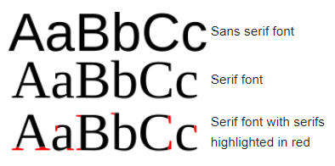  
(Wikipedia, 2019‎)

When establishing which font you are using you also need to specify the typeface, size and modifiers like bold, italics and underline.

Custom fonts can be downloaded and added to the website or app or they can referenced online, if referenced there should always be a backup.

Many website offers fonts that then can references inside html or you could download and installing a fonts then reference them.  
(Philip Westfall, 2018)

## Usability

Text can have a big impact on any document, app or website but also be easy to read and compatible with all types of programs, devices and browsers.

To make text more usable for the reader you essentially breaking up information so relevant text stands out.  
This could a visually with bullet points or bold text. It could be done with just text by using interesting word choices rather than repeating words.  
Other strategies include using an active voice like including the user name in a text interaction or using general words when referring to jargon heavy terms even offering links to a description.  
A final options is to not even use text and rather opt for an interactive element like a video with text.  
(8DAYS, 2019)

## Considerations

### Project

Text incorporated into my app needs to address the players name directly and offer references for any jargon heavy terms. Pages should not consist of much text and be filled with images or interactive elements.

The game my project is based on has its own built in custom fonts so keeping usability in mid using these custom fonts would be great for user experience.  
These fonts need to analyse and decision of which one should be used for my app needs to be made.

### Development platform

There is no restriction on fonts inside Visual Studio and default fonts are not required since the app is installed on the phone.  
(DuPreez, 2017)

Xamarin also has no restriction of fonts and even has extra functionality inside there forms to change Font Size and Font Attributes, This is very similar to websites.  
(Microsoft, 2019)

### Expert

No real experts opinions on just the best practises of fonts on android but instead there are tutorials for how apply fonts with best practises.  
Since fonts can applied at any stage of text developments iterating or updating fonts can make text more striking and impactful. This would push the user experience and you could even offer font options within the app.  
(Sheeter, 2017)

### Project Criteria

The fonts used in the game are as follows:

FixedSys:   
This font is used for the terminals inside the fallout game and is based on the old windows notepad font. (Silcher, 2012)

Monofonto:   
This is the closest font to the one that is used in fallout with the pip boy (a personal computer). (fonatica, 2015)

Overseer:   
This font is used on promotion material and logos for the game, while not in the game it is associated with it. (Sagas, 2019)

For this project things to consider are:   
The available text and numbers also how uniform they are.  
Visual Impact of the text.  
How easy it is to read.  
If there are any copyright considerations.

## Quality assessment

|  |  |  |  |  |
| --- | --- | --- | --- | --- |
| Font | Alphabet & Numbers | Visual Impact | Easy to read | Copyright |
| FixedSys | α Ａ ⒜ Ⓐ ⓐ Ȁ Ȃ Ȧ Ӓ Ӑ Ʌ Ⱥ Ά Α Λ Ѧ Д ᾈ ᾉ ᾊ ᾋ ᾌ ᾍ ᾎ ᾏ • ȁ ȃ ɑ ɒ ɐ ȧ α ά Δ д ӓ ӑ ᾀ ᾁ ᾂ ᾃ ᾄ ᾅ ᾆ ᾇ ᾰ ᾱ ᾲ ᾳ ᾴ ᾶ ᾷ abcdefghiklmnopqrstvxyz ABCDEFGHIKLMNOPQRSTVXYZ 0123456789!@#$%^&*()<>?:”{}|\[]  Even all A’s present with Uniform characters 10/10 | Impactful but is based off an old school font  8/10 | Harder to read since it is very blocky  3/10 | Technically owned by Microsoft but should be fair use.  8/10  Total: 29 |
| Monofonto | α Ａ ⒜ Ⓐ ⓐ Ȁ Ȃ Ȧ Ӓ Ӑ Ʌ Ⱥ Ά Α Λ Ѧ Д ᾈ ᾉ ᾊ ᾋ ᾌ ᾍ ᾎ ᾏ • ȁ ȃ ɑ ɒ ɐ ȧ α ά Δ д ӓ ӑ ᾀ ᾁ ᾂ ᾃ ᾄ ᾅ ᾆ ᾇ ᾰ ᾱ ᾲ ᾳ ᾴ ᾶ ᾷ  abcdefghiklmnopqrstvxyz ABCDEFGHIKLMNOPQRSTVXYZ 0123456789!@#$%^&*()<>?:”{}|\[]  None of the A’s and numbers bot oddly long brackets 6/10 | Nothing really impactful, average font  5/10 | 10/10 | 10/10  Total: 31 |
| Overseer | α Ａ ⒜ Ⓐ ⓐ Ȁ Ȃ Ȧ Ӓ Ӑ Ʌ Ⱥ Ά Α Λ Ѧ Д ᾈ ᾉ ᾊ ᾋ ᾌ ᾍ ᾎ ᾏ • ȁ ȃ ɑ ɒ ɐ ȧ α ά Δ д ӓ ӑ ᾀ ᾁ ᾂ ᾃ ᾄ ᾅ ᾆ ᾇ ᾰ ᾱ ᾲ ᾳ ᾴ ᾶ ᾷ  abcdefghiklmnopqrstvxyz ABCDEFGHIKLMNOPQRSTVXYZ 0123456789!@#$%^&*()<>?:”{}|\[]  None of the A’s and font very small and close together 4/10 | 10/10 | To bunched up and small by default 8/10 | Owned by Pixel Sagas and has free for personal use only licence 0/10  Total: 22 |

## Conclusion

FixedSys and Monofonto where close but since FixedSys is dated and owned by Microsoft so Monofonto came out on top.

Monofonto might have weird long brackets but this won’t impact the overall familiarity people will have, with the font used in the app and the one in the game.  
A default font will have to be set in place for any letter not in Monofonto. The more average looking Monofonto will be an advantage when paired this with other fonts.

# Storyboard & Wireframe

## Introduction

Both serve a clear purpose to map out site interaction, content, layout, themes, and overall design of the given interface or GUI.

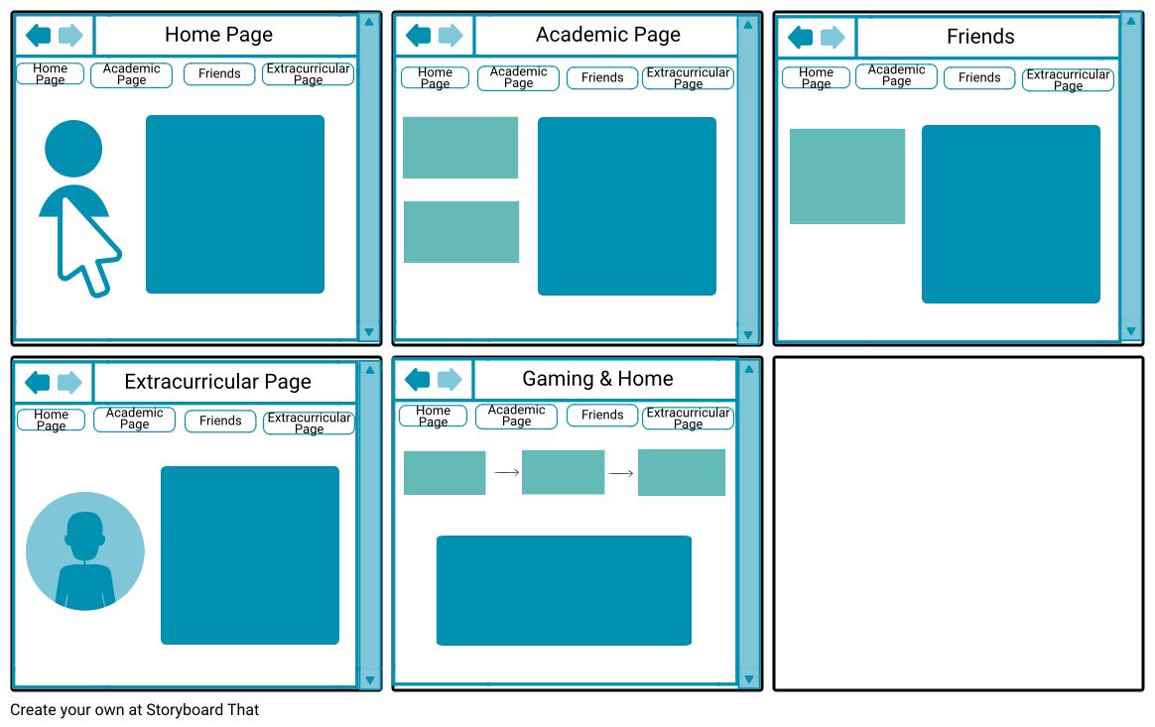  
(gurpreet2002, 2018)

### Storyboard

* As the name implies lays out a GUI interaction in a story board.
* It is also used for the layout of each page and not only the interaction.
* Should represent a desired outcome or themes of the GUI.
* A story board could consist of a wireframe or many based on how you go about the design.

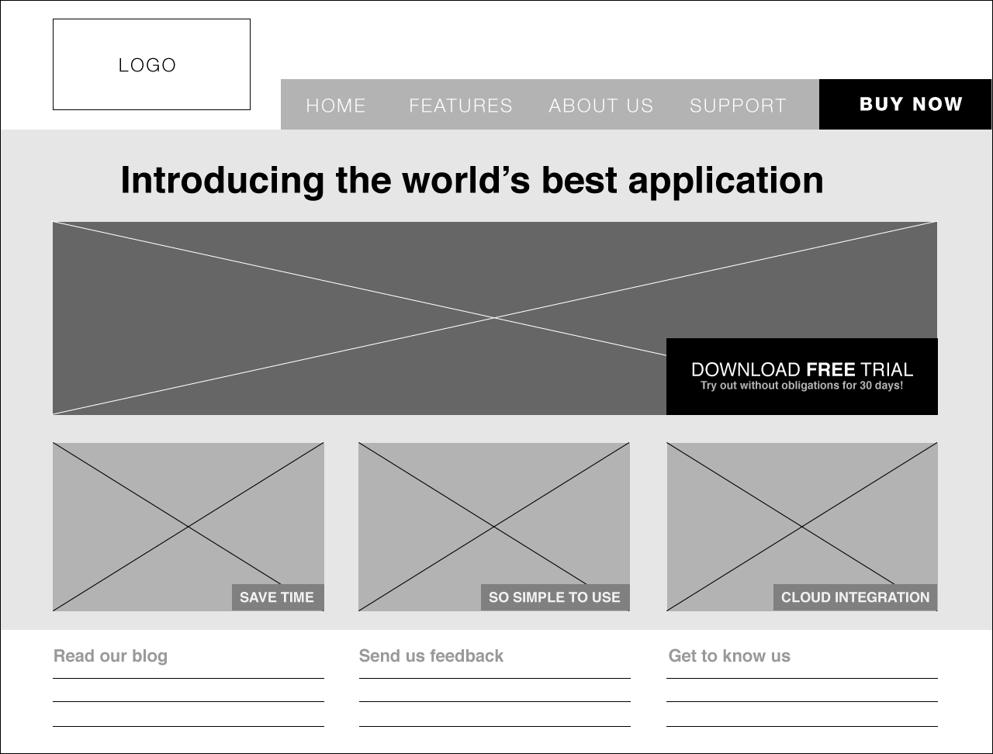  
(Lim, 2012)

### Wireframe

* Although similar to a storyboard it does not necessarily describe GUI interaction.
* Wireframes have a heavy emphasis on design or content layouts.
* Often accompanied with labels or a glossary of information for each GUI element
* This glossary will describe the element rather than a mock example.

(Smith)

In my option a storyboard is a clear picture example of a site interaction like logging in. While a wireframe would just be the layout and design of the login but at certain point you can just merge them.

## Usability

Storyboards and wireframes are super useful and are an easy way to visualize the structure of the GUI. Whether you fuse the wireframe, storyboard and even site map together is up the designer but the effectiveness of each can’t be understated.  
The storyboard is really a showcase of the GUI’s usability before any development takes place. This could help with acceptance testing or interface testing early on.  
Over all it will help refine client specification and make Content Development More Effective.

(CommLab India Bloggers, 2012) (Edraw)

## Project consideration

The role of a storyboards in my project will be layout not only how many activities (pages) I need but any special requirements for those activities. The built in navigation bars in Xamarin offer a good starting point but activity content needs some formatting especially around form(element) constraints like if they are scrollable or not(it’s not built in like html).  
Some activities will be hidden within others and this may prompt a story board that has a few steps or interactions for example to level up you maybe need 2 activities (screens) for picking SPECIAL and Perk cards.

## Conclusion

To sum up storyboards will be useful for managing the project since it will keep my activities to a minim and help refined my constraints early before I add content that may not fit the screen.  
Xamarin environment makes it very easy to implement navigation, activities and forms so it may be preferable to make the storyboard within the development environment.

# User Experience

## Introduction

User Experience or UX is not just the look of the interface but the overall feel of the products. The user needs to be the focus throughout the entire development since they are the true stakeholders.

1. What does my desired audience like and how can satisfy them?
2. What requirements will my audience expect from a program like this?
3. Designing the user experience based of the requirements.
4. Evaluate the desired audience with an acceptance test.

Can I answer all these user-centred design questions?  
The platform will also need to be considered since people using let’s say IPhone will expect a certain level of quality or even feature to be present like a notification integration.

(Interaction Design Foundation)

## Usability

Usability is a part of the User Experience. It really describes how effective the interface or program is in conveying its information. The customer has an expectation or goal in mind with the app, well can the app achieve this and go above and beyond their expectations.

* It should be easy for the user to become familiar with the program it should covey the expectation of the customers needs.
* It should be easy for users to achieve their objective through using the program.
* It should be easy to for them to navigate interface and how to use it on subsequent visits.

These point really a good explanation of how to achieve good usability.

(Interaction Design Foundation)

## Project consideration

The audience for my app is middle age and are full time employees. They need the best usability to make sure there use of the app saves time. They need to be invested in the app because they are invested in there gaming experience so nothing should break that.

* Seamless likeness from the game to the app.
* Information needs to accurate so it doesn’t frustrate the audience.
* Navigation should me seamless and very interactive.
* Potential for references or tips of how to use the app as popups.

## Conclusion

Really as long as I get the likeness correct the accuracy and navigation can be worked on through the prototypes. It needs to look and feel like a fan of the game made this app and not someone looking for money.  
I’m targeting the working fallout fan-base so a premiere time saving app is the goal.

# Conclusion

This app will take on the big task of replicating the fallout 76 character building the Xamarin development environment. The audience will expect at the very least a very similar experience to what they have in fallout 76 but of course I will not be able to copy any assets that are held by Bethesda’s copyright.

All deliverables should be highest quality since not only does the audience have the desire for it but I want to keep that likeness to immersion from the game. The size of the app or speed of running it won’t be an issue in mind since the audience will most likely have expensive phones.

The construction of the app needs to keep considerations for expanded features in the future especially around the database since a browser or executable version for pc would be a great addition and having your build shared between devices would offer a better user experience.

Finally the use of Xamarin and the Visual studio platform offers many tools and compatibility with many devices and deliver types.

# References

8DAYS. (2019, FEBRUARY 6). *11 Golden Rules of Writing Content for Your Website | Jimdo Blog*. Retrieved from www.jimdo.com: https://www.jimdo.com/blog/11-golden-rules-of-writing-website-content/

Abbas, W. (2019, Feb 13). *What's the Best Image Format? Different File Formats & Their Features*. Retrieved from enviragallery.com: https://enviragallery.com/whats-the-best-image-format-different-file-formats-their-features/

Android. (n.d.). *Supported media formats  |  Android Developers*. Retrieved from developer.android.com: https://developer.android.com/guide/topics/media/media-formats

Bognar, A. (2019, Jan 8). *Embracing Your Animated Future - MovingUI - Medium*. Retrieved from medium.com: https://medium.com/movingui/embracing-your-animated-future-67f963063251

Chastain, S. (2019, July 05). *The Best Image Format Types for Different Needs*. Retrieved from www.lifewire.com: https://www.lifewire.com/which-graphics-file-format-is-best-1701773

CommLab India Bloggers. (2012, April 06). *Advantages of Designing a Visual Storyboard.* Retrieved from blog.commlabindia.com: https://blog.commlabindia.com/elearning-design/advantages-visual-storyboard

DuPreez, H. (2017, February 6th). *Embedding Fonts in Visual Basic Apps*. Retrieved from www.codeguru.com: https://www.codeguru.com/columns/vb/embedding-fonts-in-visual-basic-apps.html

Edraw. (n.d.). *Benefits of Wireframe - Reasons to Use Wireframe.* Retrieved from www.edrawsoft.com: https://www.edrawsoft.com/benefits-of-wireframe.php

fonatica. (2015, Mar 13). *Fallout pipboy font - forum | dafont.com*. Retrieved from www.dafont.com: https://www.dafont.com/forum/read/208504/fallout-pipboy-font

G, H. (2019, January 23). *AAC Vorbis vs. Ogg Vorbis – Difference and Comparison – Diffzi*. Retrieved from diffzi.com: https://diffzi.com/aac-vorbis-vs-ogg-vorbis/

gurpreet2002. (2018, 8 31). *Web Design Storyboard Storyboard by gurpreet2002.* Retrieved from www.storyboardthat.com: https://www.storyboardthat.com/storyboards/gurpreet2002/web-design-storyboard

Holembyovskyy, Y. (2018, April 19). *Xamarin.Forms Fancy Animations – Trailhead Technology Partners*. Retrieved from trailheadtechnology.com: https://trailheadtechnology.com/xamarin-forms-fancy-animations/

Hosein, K. (2017, Feb 25). *What is the video format for phones? - Quora*. Retrieved from www.quora.com: https://www.quora.com/What-is-the-video-format-for-phones

Hughes, J. (2019, August 14). *What's the Best Image Format for Your Website? JPEG vs PNG vs GIF*. Retrieved from themeisle.com: https://themeisle.com/blog/best-image-format/

Interaction Design Foundation. (n.d.). *What is Usability? | Interaction Design Foundation.* Retrieved from www.interaction-design.org: https://www.interaction-design.org/literature/topics/usability

Interaction Design Foundation. (n.d.). *What is User Experience (UX) Design? | Interaction Design Foundation.* Retrieved from www.interaction-design.org: https://www.interaction-design.org/literature/topics/ux-design

Lim, W. (2012, Jun 18 ). *A Beginner’s Guide to Wireframing.* Retrieved from webdesign.tutsplus.com: https://webdesign.tutsplus.com/articles/a-beginners-guide-to-wireframing--webdesign-7399

Microsoft. (2017, 04 26). *Animations for Visual Studio - Visual Studio | Microsoft Docs*. Retrieved from docs.microsoft.com: https://docs.microsoft.com/en-us/visualstudio/extensibility/ux-guidelines/animations-for-visual-studio?view=vs-2019

Microsoft. (2017). *xamarin animation example - Google Search*. Retrieved from docs.microsoft.com: https://docs.microsoft.com/en-us/samples/browse/?products=xamarin&term=Xamarin.Forms+Animation

Microsoft. (2019, 28 06). *Fonts in Xamarin.Forms - Xamarin | Microsoft Docs*. Retrieved from docs.microsoft.com: https://docs.microsoft.com/en-us/xamarin/xamarin-forms/user-interface/text/fonts

Microsoft. (n.d.). *File types supported by Windows Media Player*. Retrieved from support.microsoft.com: https://support.microsoft.com/en-nz/help/316992/file-types-supported-by-windows-media-player

Microsoft. (n.d.). *Free IDE and Developer Tools | Visual Studio Community*. Retrieved from visualstudio.microsoft.com: https://visualstudio.microsoft.com/vs/community/

Microsoft. (n.d.). *Image Class (System.Drawing) | Microsoft Docs*. Retrieved from docs.microsoft.com: https://docs.microsoft.com/en-us/dotnet/api/system.drawing.image?view=netframework-4.8

Microsoft. (n.d.). *Image Editor - Visual Studio | Microsoft Docs*. Retrieved from docs.microsoft.com: https://docs.microsoft.com/en-us/visualstudio/designers/image-editor?view=vs-2019

Microsoft. (n.d.). *Images in Xamarin.Forms - Xamarin | Microsoft Docs*. Retrieved from docs.microsoft.com: https://docs.microsoft.com/en-us/xamarin/xamarin-forms/user-interface/images?tabs=windows

Microsoft. (n.d.). *videostudio-x10*. Retrieved from help.videostudiopro.com: http://help.videostudiopro.com/videostudio/v20/main/en/documentation/index.html#page/videostudio-x10/h2-supported-file-formats.html

Pablo Stanley. (2018, Mar 6). *Good to great UI animation tips - UX Collective*. Retrieved from uxdesign.cc: https://uxdesign.cc/good-to-great-ui-animation-tips-7850805c12e5

Philip Westfall. (2018, October 5). *The Easy Way to Add Fonts to Your Website (Including Custom Fonts)*. Retrieved from www.pagecloud.com: https://www.pagecloud.com/blog/how-to-add-custom-fonts-to-any-website

Ricker, K. (2019, February 8). *Customizing Your Xamarin.Forms Apps with Animations| ComponentOne*. Retrieved from www.grapecity.com: https://www.grapecity.com/blogs/customizing-your-xamarin-forms-apps-with-animations

Sagas, P. (2019, Aug 24). *Overseer Font - FontSpace*. Retrieved from www.fontspace.com: https://www.fontspace.com/pixel-sagas/overseer

SageSolus. (2018, Dec 24). *What system do you play on - Results - Straw Poll.* Retrieved from www.strawpoll.me: https://www.strawpoll.me/17102854/r

Sheeter, R. (2017, Dec 6). *The Android Developer’s Guide to Better Typography - Google Design - Medium*. Retrieved from medium.com: https://medium.com/google-design/the-android-developers-guide-to-better-typography-97e11bb0e261

Silcher, T. (2012, Jun 1). *RobCo Termlink BIOS Font - Fallout New Vegas - forum | dafont.com*. Retrieved from www.dafont.com: https://www.dafont.com/forum/read/52773/robco-termlink-bios-font-fallout-new-vegas

Smith, E. (n.d.). *What Is Storyboarding in Web Design? | Techwalla.com.* Retrieved from www.techwalla.com: https://www.techwalla.com/articles/what-is-storyboarding-in-web-design

Soundtrap. (2019, mar). *Mp3 vs Ogg vs Wav (High quality download) – Soundtrap Support*. Retrieved from support.soundtrap.com: https://support.soundtrap.com/hc/en-us/articles/360012418214-Mp3-vs-Ogg-vs-Wav-High-quality-download-

Wikipedia. (2019‎, August 18 ). *Typeface - Wikipedia*. Retrieved from en.wikipedia.org: https://en.wikipedia.org/wiki/Typeface

Yetteh. (2016). *The demographics for the Fallout 4 community.* Retrieved from google.com: https://docs.google.com/forms/d/e/1FAIpQLSdWsBGm9wJz7B_GYCmfm1pHqbA9PpZS5i09yIfIg9Z7y208sg/viewanalytics